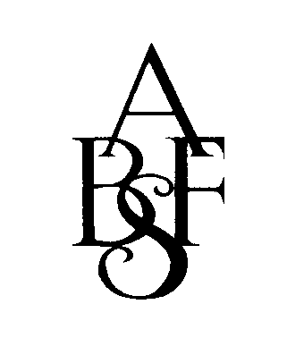

British Academy of Forensic Sciences

Clozapine and Treatment Resistance – CRESTAR

Workshop: Clozapine Therapeutic Drug Monitoring

Saturday 28 June 2014

Robens Suite, Guy’s Hospital, London Bridge, London SE1 9RT

09.30 | Registration/Coffee
10.20 | Welcome and Introduction | Dr James MacCabe (Institute of Psychiatry)
 | Background – Chair Dr James MacCabe
10.30 | TDM of antipsychotics | Prof Dr Christoph Hiemke (Univ of Mainz)
11.15 | TDM of clozapine: UK Perspective | Prof Bob Flanagan (King’s College Hospital)
12.00 | Psychiatrist’s attitudes to antipsychotic TDM/clozapine assay service provision | Dr Maxine Patel (Institute of Psychiatry)
12.20 | Role of the Mental Health Pharmacist | Nicola Holmes (Birmingham and Solihull Mental Health Trust)
12.40 | Discussion
13.00 | Lunch
 | Difficult Issues – Chair Prof Bob Flanagan
13.30 | Smoking | Dr Inti Qurashi (Ashworth Hospital)
13.40 | Men vs women | Dr Fiona Gaughran (Institute of Psychiatry)
13.50 | Gastrointestinal hypomotility | To be confirmed
14.00 | Metabolic effects | Dr Emilio Fernandez-Ega (Cambridge)
14.10 | Off-label uses (e.g. children, high dose) | Siobhan Gee (South London & Maudsley Mental Health Trust)
14.20 | Augmentation | Dr Sarah Proctor (Bowmore Hospital)
14.30 | Discussion/Tea
 | Medico-legal Issues – Chair Prof Christoph Hiemke
15.00 | Clozapine TDM in forensic psychiatry | Prof Bob Peckitt (Norwich)
15.30 | Investigation of clozapine-related deaths | Prof Bob Flanagan (King’s College Hospital)
16.00 | Concluding remarks/General discussion | Dr James MacCabe (Institute of Psychiatry)

Cost to include lunch and refreshments – 4 accredited CPD Points
Discounted rate for BAFS members/CRESTAR participants/Students/Trainees - £25.00
Register at www.bafs.org.uk (PayPal accepted) or by email to lesley@bafsadmin.org or by post using this form
.............................................................................................................................

BAFS members/CRESTAR participants/Students/Trainees £25.00 ……….. Other Places £50.00 ..............

Total enclosed £ ................ Please make cheques payable to BAFS or pay online www.bafs.org.uk
28 June 2014

Name.....................................................…………………………………………………..
Address/DX................................................................................................................................................................................

Tel/Mob...........................………...................Email..............................…………....................................................................

Lesley Nott, BAFS, Franklin-Wilkins Building, King’s College London, 150 Stamford Street, London SE1 9NH

